Data Modelling & SQL Language
2020– Semester-2, Year 1

Table of Contents:

- Introduction
- Theory
2a) Task 1: SQL (Structure query language)
2b) Task 2: DML (Data Manipulation)
2c) Task 3: Database Testing
- References

Introduction:

In this project, I have to implement the data modelling which nothing but the visual representation of database system. the goal of the modelling is to define the data and its types used in the system. we can say it is the first step to process the database. It includes data exists in the database and the relationship between data attributes and the data constraints. Also, there is different sub task in which I have define structure query language and its types and functions by implementing the given SQL queries in database.

Theory:

Task 1:

Structure Query Language:

Structure query language also called as SQL language. SQL is used to create, update and manage the database for particular data in define database. It also known as standard query language for database. It organizes the data in table form which are connected by the common field.

SQL Commands:

SQL commands is the way to instruct the system to communicate with the database. It can perform different operations with the help of these commands. there are three types of commands include for manage the database which are:
- DDL (Data Definition Language): These commands are those in which data definition language are auto committed it means it saves all the changes in the database permanently. Some commands come in DDL which are:
CREATE, ALTER, DROP, TRUNCATE, COMMENT, RENAME.

- DML (Data Manipulation Language): These commands can modify the database. It effects he entire database. They can be rollback. Commands includes in this manipulation language are:
Insert, Update, Delete.

- DCL (Data Control Language): These commands are responsible to grant and revoke the authority from any database user. Commands include are:
Grant, Revoke

Answer1: Data definition language:
Data definition language manage the data in tables with the help of create, delete and alter. Data definition language consists some commands some are as follows:
CREATE: Create command use to design the object and their schema in table and view form.
To design a database, we will use SQL queries as:
CREATE DATABASE (Database name);
Once the database has created, we have to use it in the form of queries:
USE (database name);
Then after creating and use the table in the view of database we have to create tables in the database according to flow data of the system, to create a table in the database we use query as below:
CREATE TABLE (Table Name) (attribute1 datatype, attribute 2 datatype, attribute 3 datatype, ...);
Example of CREATE statement:
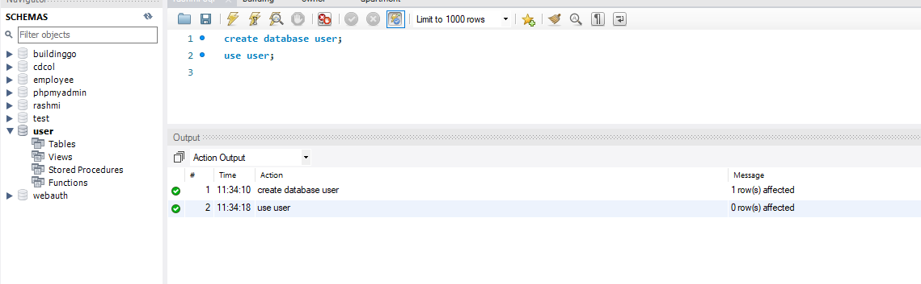
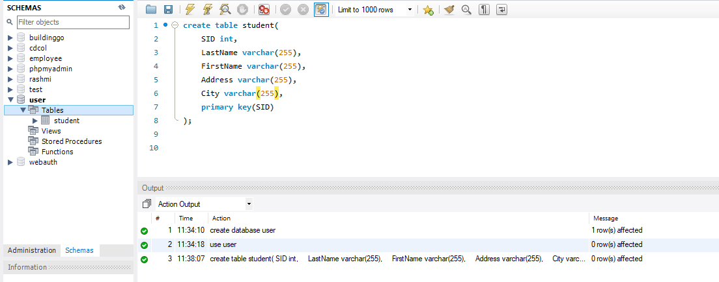

ALTER: Alter SQL command is basically use for additional, deletion and modify the table. There some uses of alter commands which are as follows:
- For adding new column into pre-defined schema
- For renaming any pre-defined attribute
- For altering the attribute properties.
- For deleting an attribute from the row and column of the table.
SQL syntax for adding the attribute in the database table is.
alter table (tablename) add (columnname) datatype;
SQL syntax for drop operation in the database table is
alter table (tablename) drop column (columnname);
SQL query syntax for changing the data type of the attribute in the database table is:
alter table (tablename) modify column (columnname) datatype;
SQL query syntax for add a Not Null value to a column in the database table is:
alter table (tablename) modify (columnname) datatype NOT NULL;

Query of Alter Example :
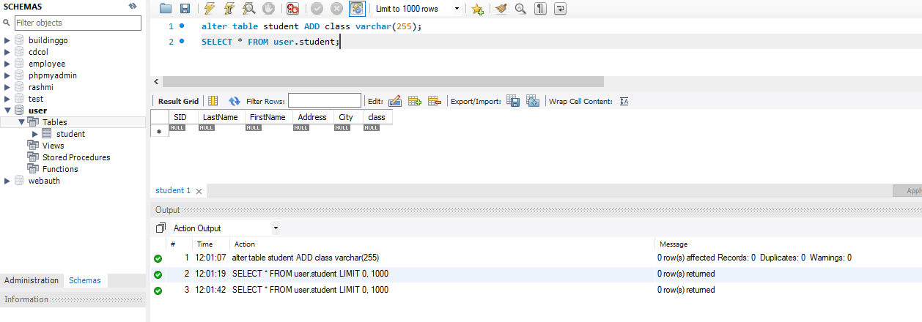

Answer 2: ACID in the relational database:
In the process of transferring money from one account to another, here you will see a database table called accounts. It has two columns first one is a customer account number and a balance. This one is a very simple form of database operations, in reality, the database used to do simple banking operations would be much more complex than this. Nevertheless, the principles of a database transaction can be demonstrated here. Suppose we wanted to transfer 1000 pounds from account 1 to account 2 then this would include subtracting 1000 pounds from the balance of account 1 and add 1000 pounds to the balance of account 2.

A database application could achieve this using two separate update queries. One update query will deduct some money from the source account and the second update query would add the same amount of money to the target account and the system might also keep the logs of these changes by inserting a new row into a table called transfers. An ACID property in DBMS makes the transaction over the database more reliable and secure. This is one of the advantages of using DBMS.
Atomicity: It guarantees either exchange is going on totally or not there is no halfway stage with respect to the exchange.
Example:
For understanding the atomicity conduct consider, the course of action of exercises are
· Debited the proportion of $10 from Tom account.
· attributed the proportion of $10 to Jerry account.
All exercises in this set should be done. In case the structure fails to add the total in Jerry account ensuing to deducting from Tom account, we need the framework that returns the procedure on Tom record and Tom needs to make an exchange activity once more.
Consistency: It guarantees the soundness of the information base. The necessities that we put on the data worth ought to be predictable when the execution of the trade. In case the structure crashes and burns by virtue of the invalid data while doing a movement, in the present condition system needs to re-visitation of its past state.
Example:
The total whole in Tom and Jerry record should be the equal when the trade. The measure of the money in Tom and Jerry account when the trade is $20 for saving trade consistency.

Isolation: This property ensures that the execution, taking everything into account, should be disengaged from various trades. At a time multiple transactions are beginning a single data base, movement from any trade should not to interfere with action in various trades.
Example:
On the off chance that there is some other trade (among Mac and Tom) going, it should not to have any effect on the trade among Tom and Jerry. Both of the trades should be limited.

Durability: The sum of the over three properties should be satisfied while the trade in advancement. Nevertheless, the durability of the trade is checked after the trade is done. The movements made during the trade should exist after fulfilment of the trade.

Sometimes, all the exercises during the time spent the productive trade may be done anyway the structure tumbles immediately. Taking everything into account, changes are made while trades ought to drive forward. In this manner, the system should re-appearance of its past stable state.
Example:
It may happen if a structure gets hammered in the wake of completing of the evident huge number of undertakings or accessibility is a mishap. In light of everything, if the structure restarts it ought to ensure the consistent state. A total in Tom and Jerry record should be the comparable when the structure gets a restart.

Task 2:

Data Manipulation:
Screenshot of Query 1:

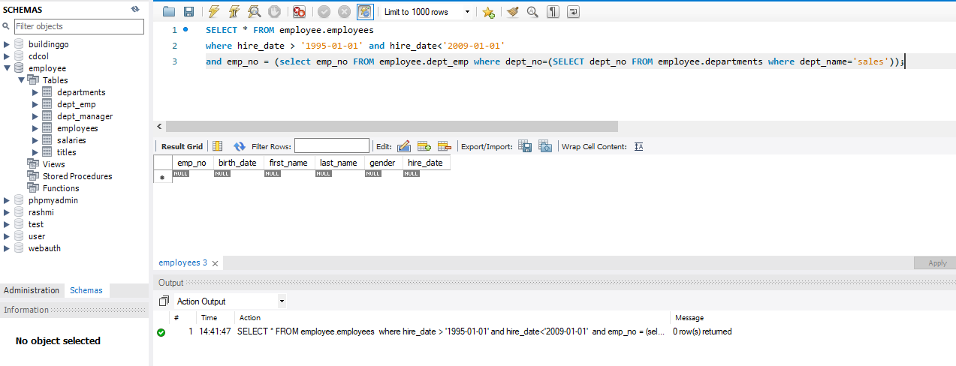

Screenshot of Query 2:

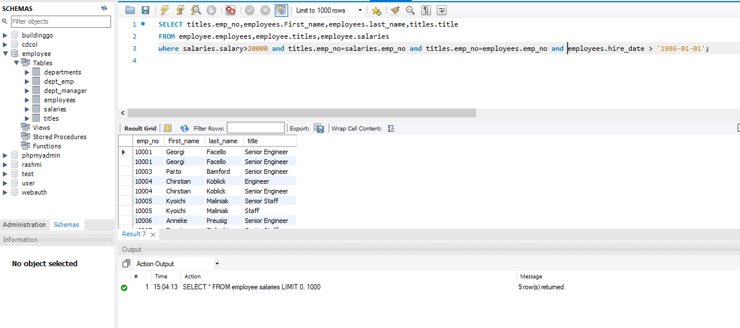

Screenshot of Query 3:

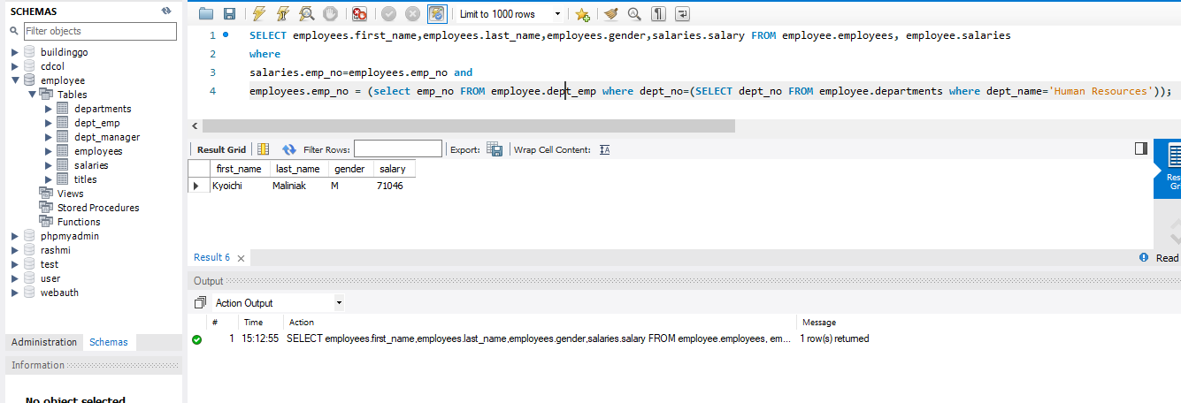

Screenshot of Query 4:
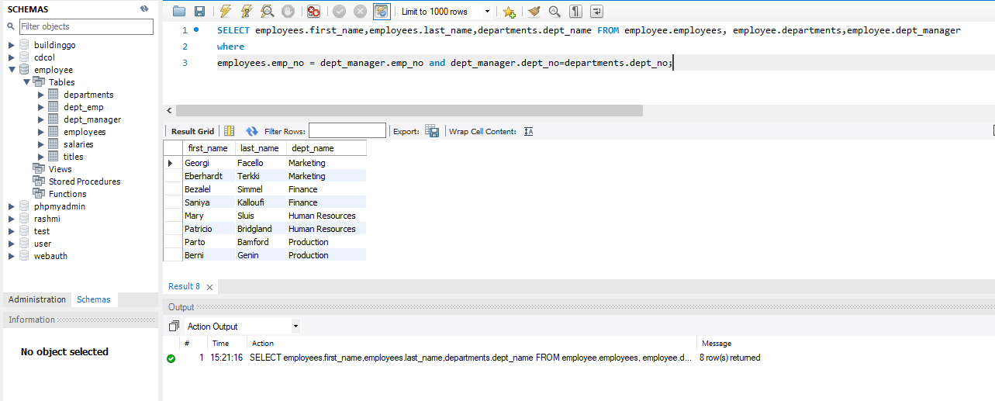

Screenshot of Query 5:

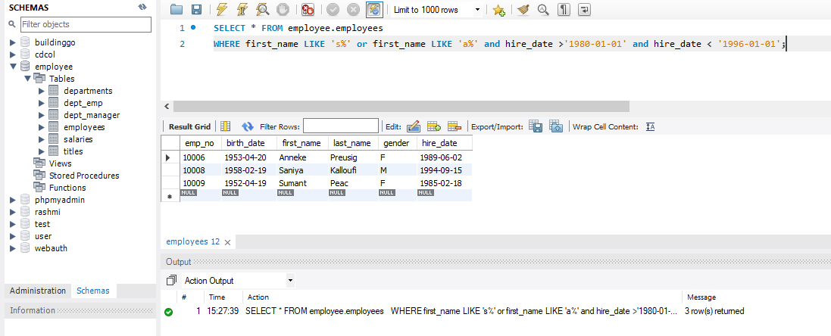

Screenshot of Query 6:

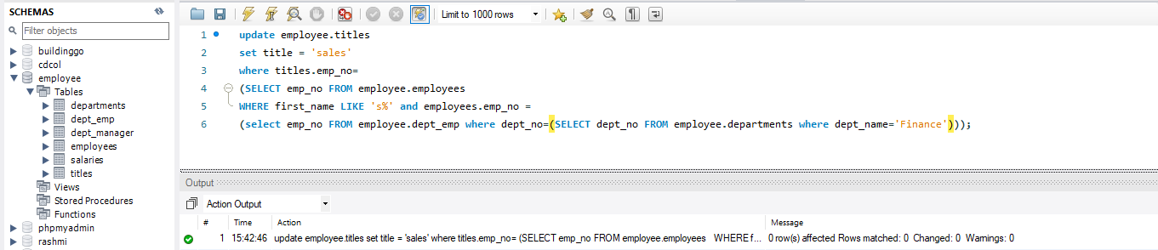

Screenshot of Query 7:

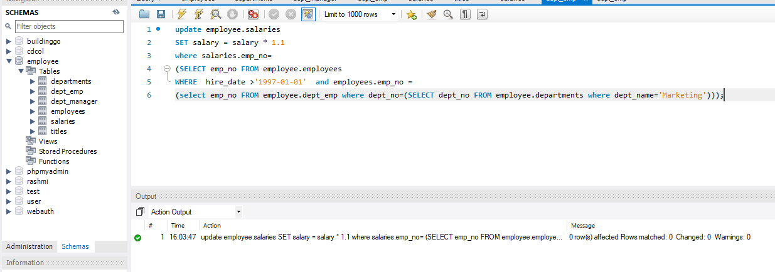

Screenshot of Query 8:

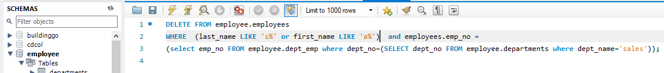

Screenshot of Query 9:

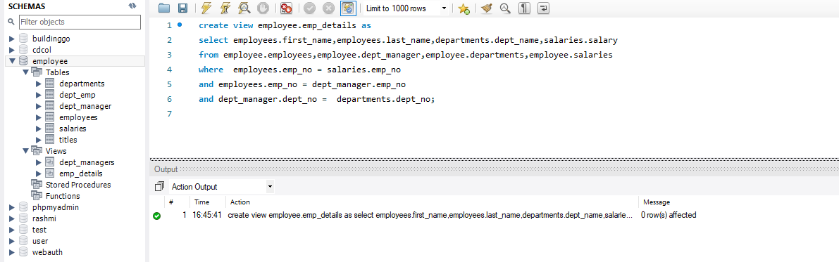

Screenshot of Query 10:

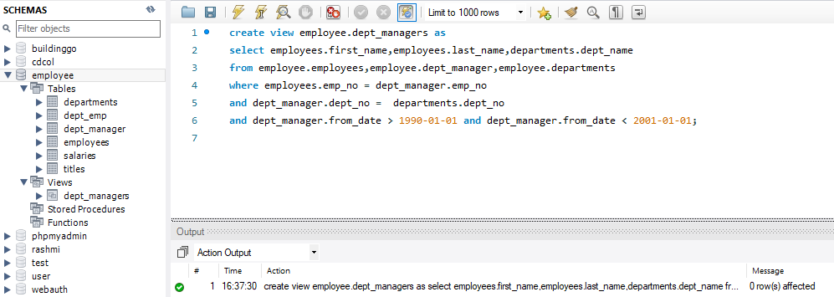

Task 3:

Database Testing:
Answer 1: Database testing
Database testing stands for in which tables, triggers, schema have to be check. Database testing also analyse the consistency an integrity of the data.
Database Testing depends on three types of testing which are:
- Functional data-base Testing
- Structural data-base Testing
- Non-functional database Testing

Importance of the database testing:
Database Testing is Important in programming testing since it guarantees that the proper functioning of the designed schema in the information base are substantial or not. Data set testing keeps the data set from unapproved admittance to the data. For any product application Database is required along these lines, the analysers must have great information on SQL for performing testing on database.

Answer 2:
In this section we have to check following constraints for the Employees database.
- Field Size validation:

Field size validation is to used to analyse the length of information obliges for field size, in the division's table of representative data set a record will be embedded with various qualities for (department_number) trait than the configuration utilized

The (department_number) is characterized as a memory bit 4 it implies it can contain a limit of four number of character type, length of the (department_number) can't be longer than eight bytes. In the wake of running the accompanying inquiry we see that (department_number) store just the initial four characters and shorten the leftover one.

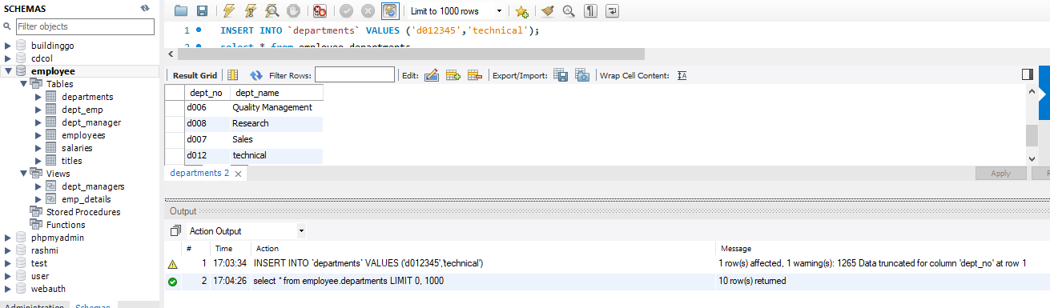

- Null values:
It analyses for the Null qualities. On the off chance that we are not characterizing invalid an incentive for a section when we make it yet giving the invalid worth when we are embeddings the information into that segment then it will display the mistake.
(first_name) & (last_name) field of the employee’s database table are characterized to not invalid but rather we leave them void during a period of intriguing worth then it shows the blunder that is plainly appeared in the yield of the inquiry appeared underneath in the depiction.

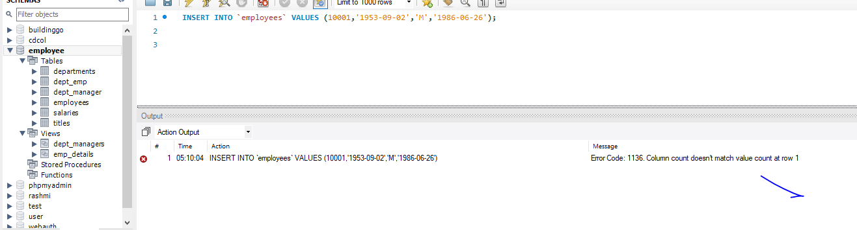

- Referential integrity (Primary/Foreign Key):
In the created database of employee that were using in the database table, (employee_number) is an essential key that is known as the primary key is utilized by employees, salary, titles, (department_manager), and (department_employee) tables. To keep up information base trustworthiness, when (employee_number) esteem is refreshed with another incentive in the representative's table, at that point this worth ought to be refreshed in all tables. To test this, a question will be utilized to change the worth '10006' from (employee_number) in the employees table to '9009'.

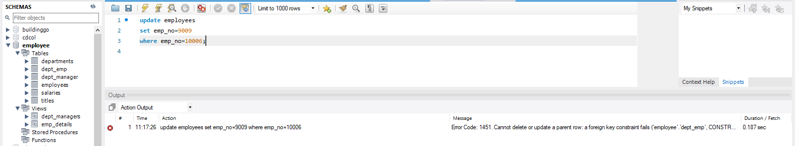

From the above preview we clearly seen that the SQL question shows a blunder message, because of the limitations implement to (employee_number). To permit the refreshed worth, traverse to all database tables, RESTRICT is set to CASCADE by sin the ON Update command. It implies we have to add 'on update course' at the hour of characterizing a table with an unfamiliar key.
While from the given screenshot depiction it is define that SQL, server permits us to erase essential/unfamiliar key worth since we add or erase course at the hour of characterizing an unfamiliar key in the database table.

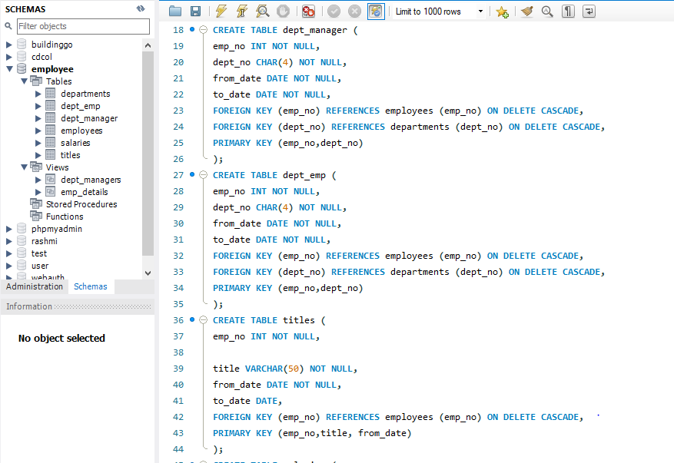

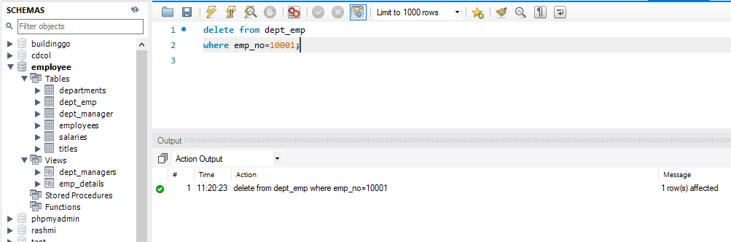

References:

- tutorialspoint, 2020. SQL – ALTER TABLE command. [Online] Available at: https://www.tutorialspoint.com/sql/sql-alter-command.htm [Accessed 24 Oct. 2018].
- tutorialspoint, 2020. Database Testing – Overview. [Online] Available at: https://www.tutorialspoint.com/database_testing/database_testing_overview.htm [Accessed 24 Oct. 2018].
- w3schools.com, 2020. SQL Tutorial. [Online] Available at: https://www.w3schools.com/sql/default.asp [Accessed 24 Oct. 2018].

